“PETGUI" Evaluation Form
"PETGUI" is a user-friendly interface for training and testing a language model using Pattern Exploiting Training (PET).
Pattern Exploiting Training (PET)
PET is a semi-supervised training strategy for language models. PET adds phrases in pattern-verbalizer pairs to the given data (here: sections from CARDIO:DE)
• Example: Section labeled "Anamnese": "Severe thoracic tightness after light exertion."
is transformed into: "The following section deals with complaints: Severe thoracic tightness after light exertion."
• The advantage of PET over other training strategies is the use of less data, resulting in a PET-trained model achieving the same (or even better) performance as one trained with standard supervised training.

Step 1: Application start
Action(s) | Expected Display | Did it work? | If not: Please describe display
Please open this link in a browser on a clinical PC | Homepage is displayed:  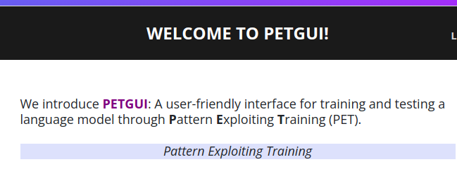 | Yes [] No []
→You are now on the Homepage

Step 2: Login
Action(s) | Expected Display | Did it work? | If not: Please describe display
- Click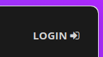 to go to the Login page | Login Page is displayed:  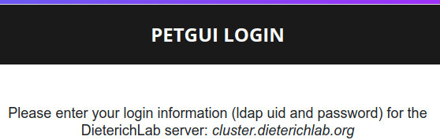 | Yes [] No []
- Fill in the "username" and "password" fields with your LDAP credentials and then click on 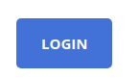 | Setup Page is displayed:  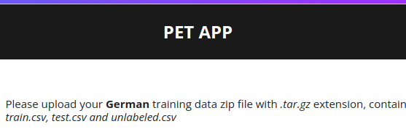 | Yes [] No []
You are now on the Setup Page

Step 3: Set up a few-shot training
Action(s) | Expected Display | Did it work? | If not: Please describe display
- Save the german few-shot data on your local machine. | “train.tar.gz” wurde auf dem PC gespeichert | Yes [] No []
- Open the verbalizer and label mappings “mappings.ods” in a separate browser tab. | Tabelle “mappings.ods” wurde geöffnet  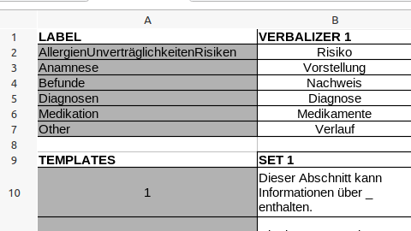 | Yes [] No []
- Click on to upload and select the downloaded training data | Datei wurde hochgeladen:  “File train.tar.gz uploaded successfully!“ | Yes [] No []
- Click onto see statistics on the uploaded training data  -  to hide them | Two graphs showing the label distribtution:  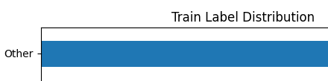…  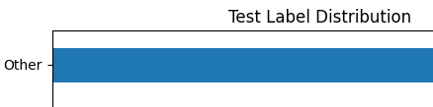  ... | Yes [] No []
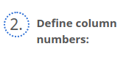  Input“1” in the left and “0” in the right field | 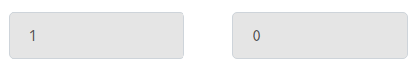 | Yes [] No []
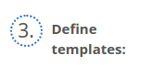  Input all three entries of the SET 1 row from the TEMPLATES table of the “mappings.ods” file | 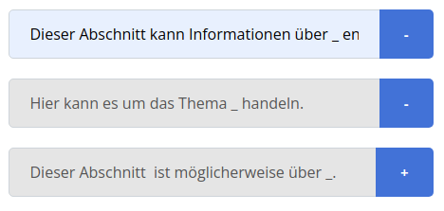 | Yes [] No []
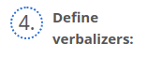  Input all entries of the VERBALIZER 1 row from the VERBALIZER table of the “mappings.ods” file | 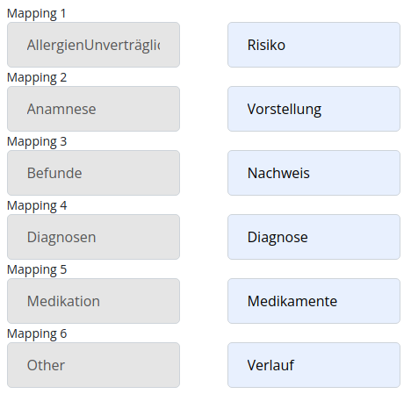 | Yes [] No []
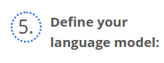  Select “gbert-base” as the language model. | 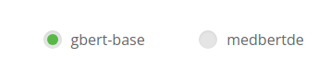 | Yes [] No []
Click “Submit” | Training Page is displayed:  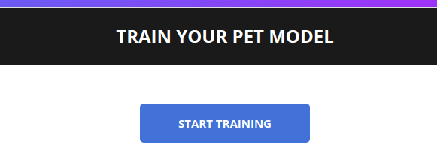 | Yes [] No []
→ You are now on the Train Page

Step 4: Train the model
Action(s) | Expected Display | Did it work? | If not: Please describe display
- Click on to start PET training  - Training is initialized. First, “Please wait” is displayed. This can take up to ~ 2 minutes.  - Then, progress bar is displayed until training finishes. | 1.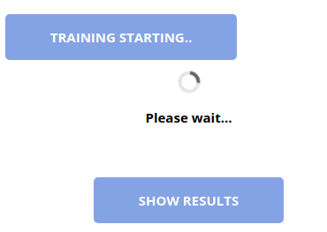  2.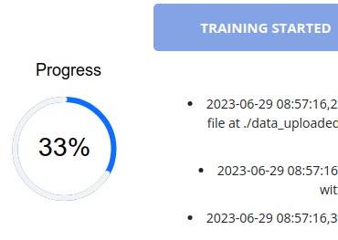  3.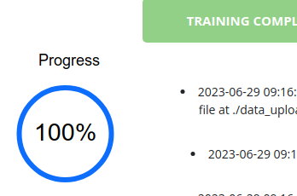 | Yes [] No []
How long did the above step take? | ~1-2 minutes ◯  ~2-3 minutes ◯  ~3-5 minutes ◯  longer ◯
- Click onto view statistics on model performance | Tabelle mit Statistiken is displayed  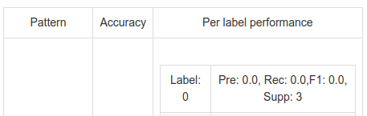  “Pre” steht für Precision, “Rec” für Recall (sensitivity), “F1” für F1-measure und “Supp” für Support (Anzahl der Samples im Test set). | Yes [] No []
Please note here the best/worst F1-scores with the according labels
Next, we adjust the training parameters and start a new training. Click on  o configure a new training. | Setup Page is displayed | Yes [] No []
→ You are now again on the Setup Page.

2. Few-shot Training
- Click on to upload and select the downloaded | Datei wurde hochgeladen:  “File train.tar.gz uploaded successfully!“ | Yes [] No []
- Click on  to see statistics on the uploaded training data  - to hide them | Two graphs showing the label distribtution:  …  ... | Yes [] No []
Input “1” in the left and “0” in the right field |  | Yes [] No []
Input all entries of the SET 2 row from the TEMPLATES table of the “mappings.ods” file | 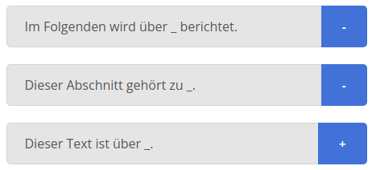 | Yes [] No []
Ginput all entries of the VERBALIZER 2 row from the VERBALIZER table of the “mappings.ods” file | 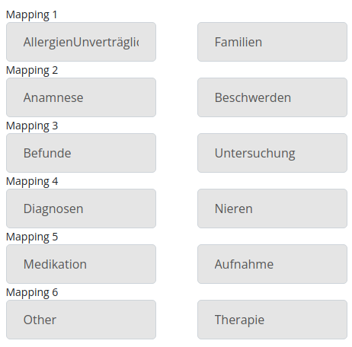 | Yes [] No []
Select "medbertde" as language model. | 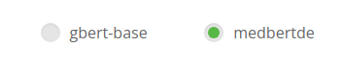 | Yes [] No []
Click “Submit” | Training Page is displayed: | Yes [] No []
→ You are now on the Training Page

Set up 2nd few-shot training
Action(s) | Expected Display | Did it work? | If not: Please describe display
- Click on to start PET training  - “Please wait” is displayed. This can take up to ~ 2 minutes.  - Wait until training progress reaches 100%. | 1.  _________________________  2.  _________________________  3. | Yes [] No []
How long did the training take this time? | ~1-2 minutes ◯  ~2-3 minutes ◯  ~3-5 minutes ◯  longer ◯
- Click onto view statistics on model performance  → Please compare the scores of the two training passes. Consider especially the F1-scores of the labels. | Table with statistics displayed | Yes [] No []
Please note here again the best/worst F1-scores with the according labels.
Click on    to annotate new doctor’s letters with the trained model. | Prediction Page is displayed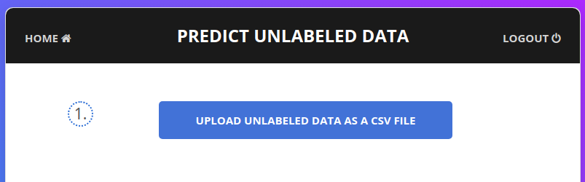 | Yes [] No []

Step 5: Generate predictions
Action(s) | Expected DIsplay | Did it work? | If not: Please describe display
Save the following file to your local machine: https://data.dieterichlab.org/s/DtBKDf57zNYWmm  Click “Upload unlabeled data as a csv file“.  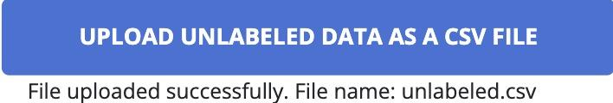 | 'File uploaded successfully: File name: data_for_prediction.csv.'  Button “Predict Labels Using PET Model” is activated. | Yes [] No []
Click "Predict Labels Using PET Model"    Please wait, this might take a while. | Button changes to "Prediction Started."  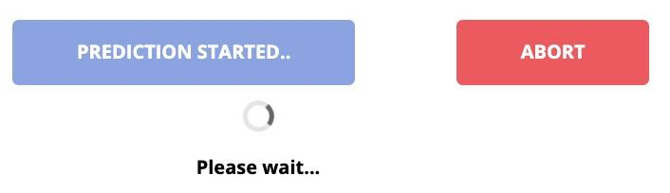  Once prediction finished, button changes to green:  Buttons "Download Predicted Data" and "Show Chart" active.
Optional: You can click "Abort" to stop prediction process and start a new prediction process. | "Prediction aborted successfully!" | Yes [] No []

Step 6: Download labeled data file
Action(s) | Expected Display | Did it work? | If not: Please describe display
Click on “Download Predicted Data“  | Labeled Data File is downloaded. | Yes [] No []

Step 7: Logout
Action(s) | Expected Display | Did it work? | If not: Please describe display
Click “Logout”  | “Logged out successfully!”  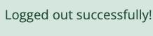 | Yes [] No []

Step 8: Evaluate PETGUI
Steps | Comments | (Your tips for improvement)
1. Start
2. Login
3. Setup Training
4. Training
5. Generate Predictions
6. Download of Labeled Data File
7. Logout

Step 9: Please rate your experience running “PETGUI”

- Reasoning: Were the app functions as buttons, texts and descriptions comprehensive for you?

Not at all 1◯ 2◯ 3◯ 4◯ 5◯ Very

Comment(s):
_________________________________________________________

_________________________________________________________

- Display: Did you find the general app display appealing?

Not at all 1◯ 2◯ 3◯ 4◯ 5◯ Very

Comment(s):
_________________________________________________________

_________________________________________________________

- Speed: Did you find that the following single processes took reasonable amount of time?

- Process 1: Training Setup - “Please Wait”
Not at all 1◯ 2◯ 3◯ 4◯ 5◯ Very

Comment(s):
_________________________________________________________

_________________________________________________________

- Process 2: Training - “Training Started”
Not at all 1◯ 2◯ 3◯ 4◯ 5◯ Very

Comment(s):
_________________________________________________________

_________________________________________________________

- Process 3: Prediction - “Prediction Started”
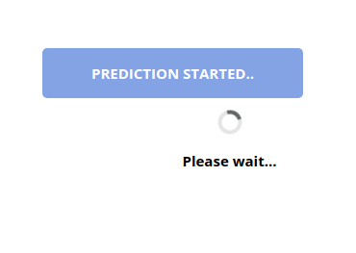
Not at all 1◯ 2◯ 3◯ 4◯ 5◯ Very

Comment(s):
_________________________________________________________

_________________________________________________________

- User interaction and feedback: Were the responses of the app as buttons, texts and descriptions helpful?

Not at all 1◯ 2◯ 3◯ 4◯ 5◯ Very

Comment(s):
_________________________________________________________

_________________________________________________________

Thank you very much for your participation! 🙂

Schick et al., 2021. Exploiting Cloze Questions for Few-Shot Text Classification and Natural Language Inference. https://arxiv.org/abs/2001.07676
Richter-Pechanski et al., 2023, A distributable german clinical corpus containing cardiovascular clinical routine doctor’s letters, Scientific Data, 10, 04 2023. doi: 10.1038/s41597-023-02128-9
A verbalizer represents the respective label in a provided template, e.g.: Label Findings OR Anamnese with a verbalizer Verification OR Complaints, respectively becomes: “This section deals with verification OR complaints.“
Given as Accuracy, Precision, Recall and F1-Score.

